AGRICULTURE 5 TERM 2 2018

1. 2.1.1.1
Define the following terms:

- Weathering

_________________________________________________________

__________________________________________________________ (1)

2.3.1.1
b) Soil fertility
___________________________________________________________

___________________________________________________________ (1)

2.3.1.2

Read the case study below and use it to answer the questions that follow.

Mrs Morule’s vegetable garden has infertile soil. Every year she does not produce good yields.

2. Mention any two management practices that Mrs Morule should carry out in order to solve the problem above.

- ___________________________________________________________

- ___________________________________________________________

2.3.1.4
The pictures below show two types of fertilizers labelled A and B. Use them to answer question 4.

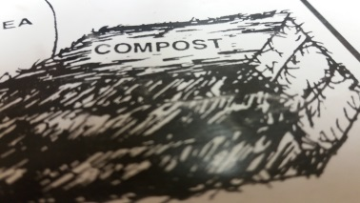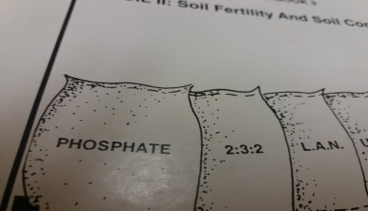
A B

3 a) Name the type of fertilizers labelled A and B.
i. ________________________________________________________ (1)

ii. ________________________________________________________ (1)

2.3.1.5

- Give one advantage of each of the above mentioned types of fertilizers.

i ___________________________________________________________ (1)

ii ___________________________________________________________ (1)

2.2.1.2

The standard five class in Dikwididi Primary School carried out an experiment as shown in the diagram below to investigate the presence of a certain soil constituent in a sample of soil. Use it to answer question 4.

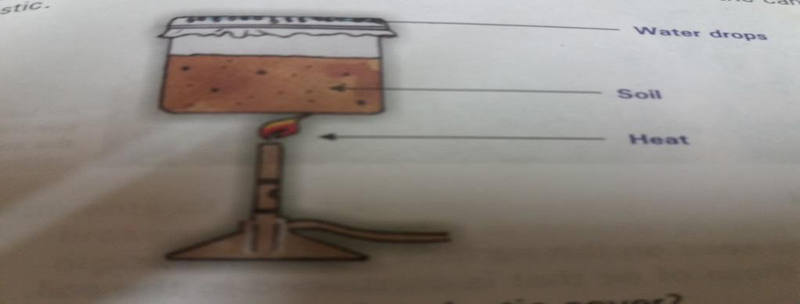

4. (a) Which soil constituent were the standard fives investigating?

Soil constituent _______________________________________________ (1)

b) What percentage is the mentioned constituent? ___________________ (1)

c) What conclusion could be drawn from the experiment above?

____________________________________________________________

____________________________________________________________ (1)

d) Give any other two soil constituents that are not mentioned above.
i) ____________________________________________________________

ii) ____________________________________________________________ (2)

5. 1.3.1.2
Complete the following table below by writing down the correct missing words in the spaces provided.

Farm Implement | Use
a) Disc harrow | a)
b) | Tilling the land
c) | Putting seeds and fertilizers into the soil

(3MARKS)

6. 1.1.1.5
Give any two problems faced by farmers in Botswana and suggest their solutions.
(2 marks)

1.1.1.2
Use the picture below to answer the questions that follow.
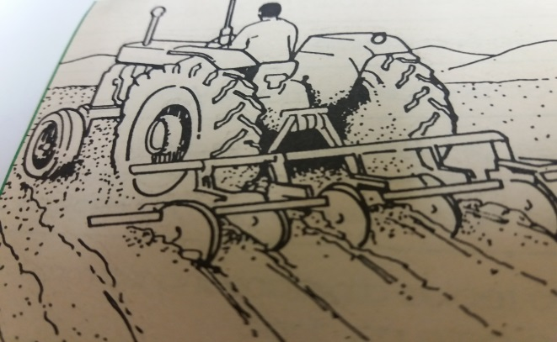

7.a) Under what branch of agriculture does the machine above fall?

___________________________________________________________ (1)

b) 1.3.1.5
State any two environmental problems that may be caused by the machine shown above.

- ___________________________________________________________

- _________________________________________________________ (2)

8. 1.4.1.2
Give any two effects of modern biotechnology

- ________________________________________________________

(ii) ________________________________________________________ (2)

1.2.1.4
Use the information and diagrams below to answer question 9 (a) and (b)

Students used different tools to conduct practical activities. After the practical one student stored the tools as shown in P another student stored the tools as shown in Q

- a) Which of the diagrams P and Q, shows the correct way of storing the tools

_____________________________________________________ 1 mark

b) Give ONE reasons for your answer in (a)

______________________________________________________ (1)

- Give any ONE example of farm tool.

_______________________________________________________________ (1)

1.1.1.8
Use the information below to answer questions that follow

Mr Kgosi owns a farm and wants to plough it, but did not have money to start ploughing. His best friend advised him on how to get the money to start ploughing. He ended up being assisted and the following year he started ploughing. However, his crops did not grow well because of some problems he encountered.

11.
a) State one government programme that can assist Mr Kgosi.

………………………………………………………………………………. (1)
1.1.1.6
b) Suggest any one problem that Mr kgosi is likely to have encountered.

………………………………………………………………………… (1)

12.Write two disadvantages of inorganic fertilizers.

a) ……………………………………………………………………………….

b) …………………………………………………………………...................(12)

1.1.1.5

13. State one way in which HIV\AIDS can affect agriculture production.

- ………………………………………………………………………………

Use the pictures below to answer question 14 (a) and (b.)


MADILA (B)
BREAD (A)

14. 1.4.1.1

- Which types of biotechnology is used to prepare product A.

_______________________________________________________ (1)

- Name the product used to make food in picture B.
______________________________________________________ (1)

15. 1.1.1.9

Give two careers in Agriculture.

- ………………………………………………………………………..

b) ………………………………………………………………………. (2)

Use the statement below to answer question 16 a and b

Mrs Kgomo is a commercial farmer with a well know vegetable garden around Gaborone. When applying fertilizers, she usually mixes and dissolve the fertilizer in water and then water the plot with the solution.

2.3.1.7
16. a) what application method of fertilizing is used by Mrs Kgomo?
……………………………………………………………………………………….

2.3.1.4

b) Which types of fertilizer is most suitable to be applied using the method named in 16 a

……………………………………………………………………………………….

1.2.1.3
17. Which farm tool is used to cultivate the soil?

………………………………………………………………………………………

1.1.1.1
18. What is agriculture?

………………………………………………………………………………………

…………………………………………………………………………………… (1)

2.2.1.1
19. Give one reason of why soil is important to us.

i…………………………………………………………………………… (1)

2.2.1.2

A student carried out an experiment on soil constituents. He put some soil sample in a bottle and added some water. Some soil particles settled at the top of the mixture.

20. Give one agent of physical weathering.

______________________________________________________ (1)

MARKING KEY STD 5 TERM 2 (2018)

1A. The breaking down of rocks to form soil
B. The ability of the soil to provide enough nutrients to the plants.
2. – adding fertilizers to the soil
- practice crop rotation
- control weeds
3. Ai organic fertilizer.
ii inorganic/ artificial fertilizer.
3b. i. it is cheap,they are found locally
ii.need less labor, easy to handle, small amount is needed

4a. water
- 25%
- There is water in the soil
- i. air
ii. organic matter, inorganic matter
5. a) breaking the lumps, levelling the soil (any one of the 2)
b) disc plough, mouldboarda plough (any one of the 2)
c) planter and fertilizer distributer

Problem | Solution
6A. POOR SOIL | ADD FERTILIZER
B.LOW/UNRELIABLE RAINFALL | BUILD DAMS
7a. agricultural engineering
b. kills animals that lives under the soil
ii. can cause soil erosion, destroy vegetation
8i)produses more food, produces food with vitamins,proteins, produces medicine and vaccines
9a. Q
9b) it cannot hurt anyone
10. SPADE, HOE etc
11a( CEDA, NAMPAAD, NDB)
B) Lack of money
12a. it is expensive
b. they do not improve the structure of the soil etc
13. more money is spent on medicine rather than on agricultural activities
b. loss of skilled personnel etc
14a. modern biotechnology
b. milk

- agricultural demonstrator etc
16a.watering/irrigation
b. inorganic fertilizer
17. digging fork/ hand fork
18. is the growing of crops and rearing animals
19. we build houses; we grow crops in the soil
20. blowing wind, running water

